Original Image:

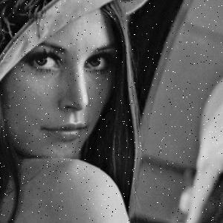

Resulting Image:

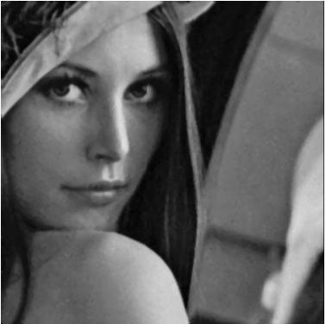

References:

<https://medium.com/@florestony5454/median-filtering-with-python-and-opencv-2bce390be0d1>

<https://numpy.org/doc/stable/reference/generated/numpy.array.html>

<https://numpy.org/doc/stable/reference/generated/numpy.zeros.html>

<https://pillow.readthedocs.io/en/stable/reference/Image.html>

<https://www.geeksforgeeks.org/spatial-filters-averaging-filter-and-median-filter-in-image-processing/>